Technical University of Cluj-Napoca
Automation and Computer Science Faculty
Automation and Applied Informatics

Student : Rad Emilian-Antonio | Coordinator:
Group: 30313 | Assist. Eng. Dan Gota
2021-2022

Description and Objective:

The program that I made represents a cube that spins and changes direction when the mouse is clicked. The cube is beatuifull colored and it spins at a pretty good speed.

The Source Code:
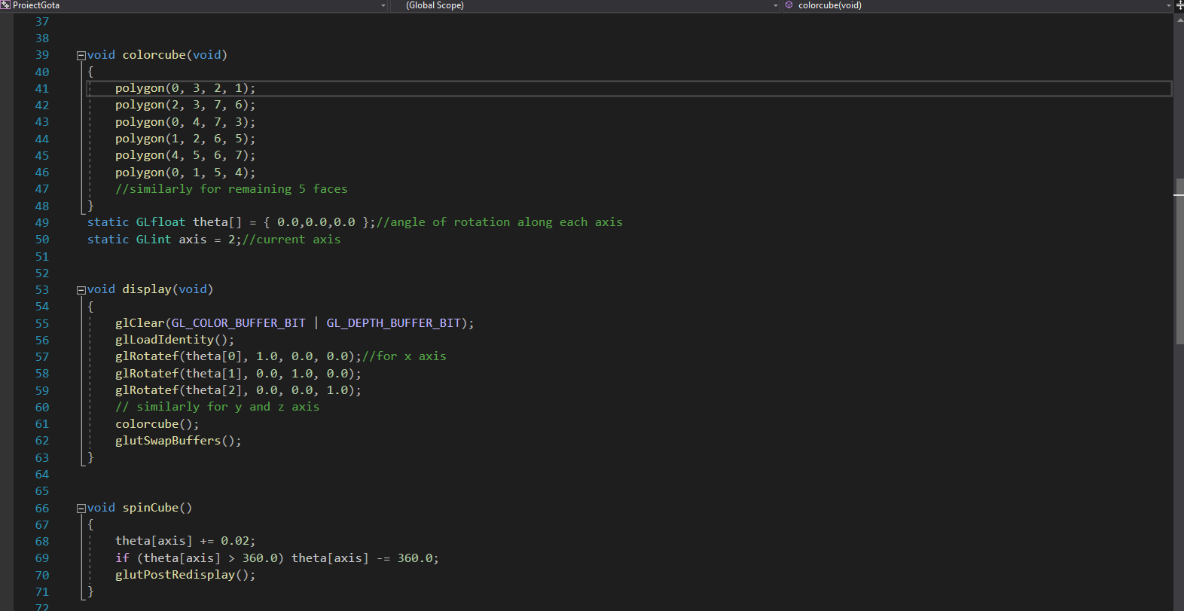
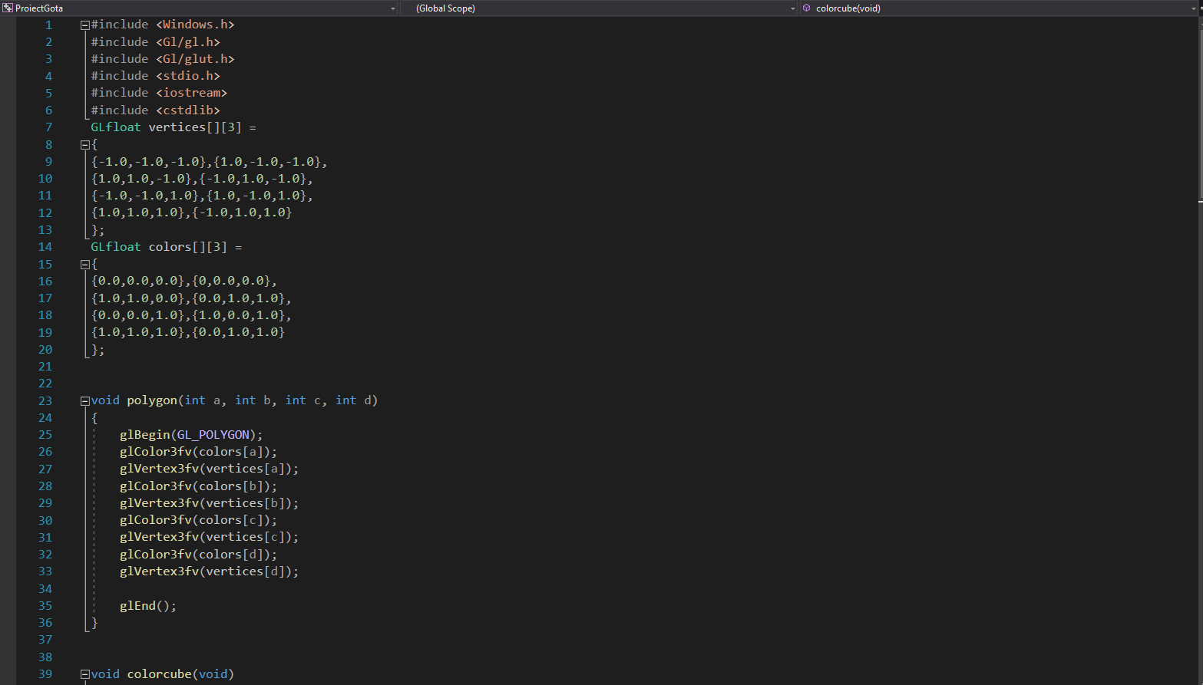
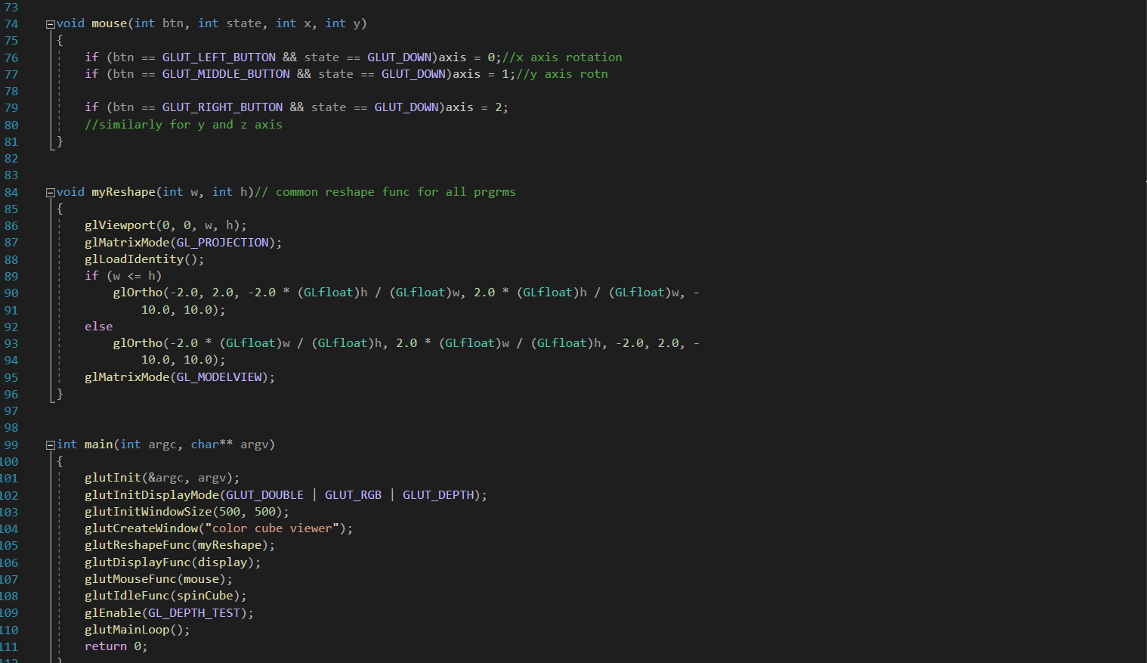

Output:

